**Assignment #6 - MongoDB Part 2**

**Perform the following operations in MongoDB using the store database/collection created in class:**

Q1: Create a query that returns the item, warehouse, quantity and status of elements with quantity < 10 (not qty)

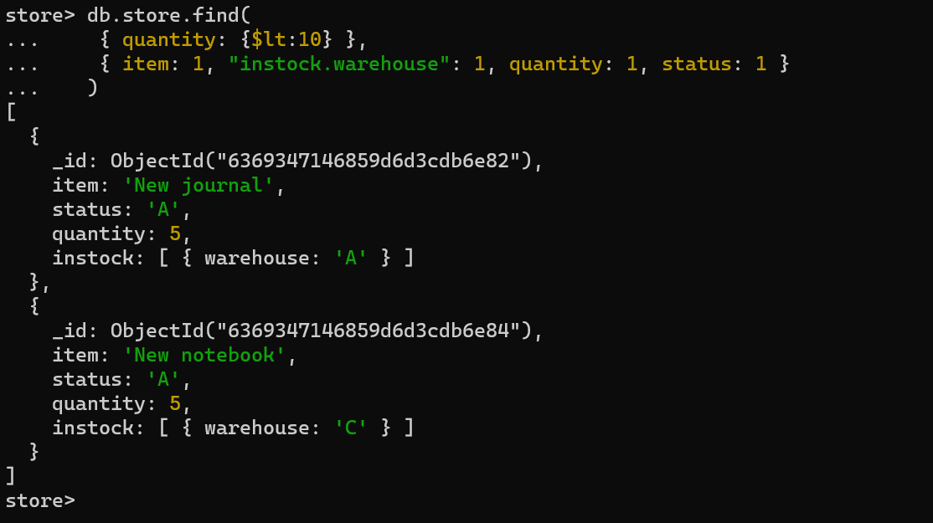

db.store.find({ quantity: {$lt:10} },{ item: 1, "instock.warehouse": 1, quantity: 1, status: 1})

Q2: Sort elements from previous query (Q1) by quantity in descending order

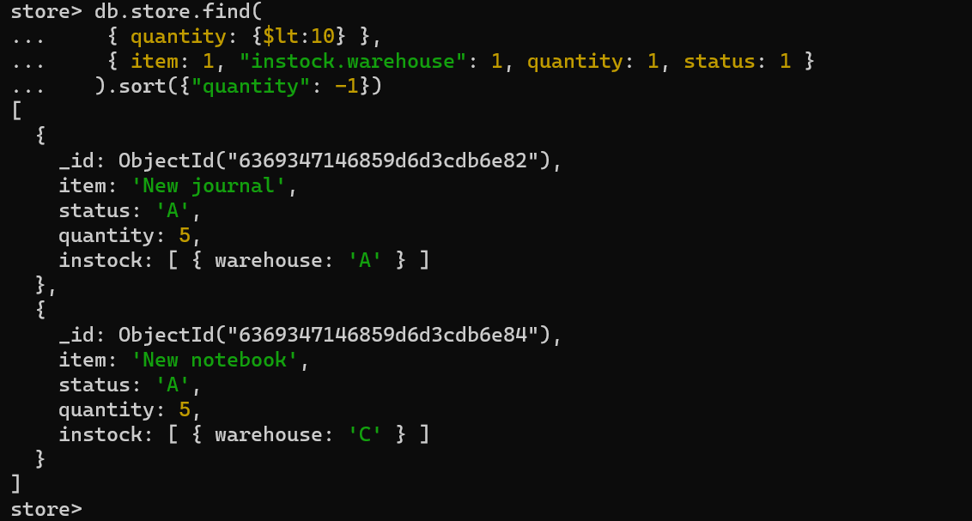

db.store.find( { quantity: { $lt: 10 } }, { item: 1, "instock.warehouse": 1, quantity: 1, status: 1 }). sort({ "quantity": -1 })

Q3: Repeat the previous query (Q2) using aggregation pipeline

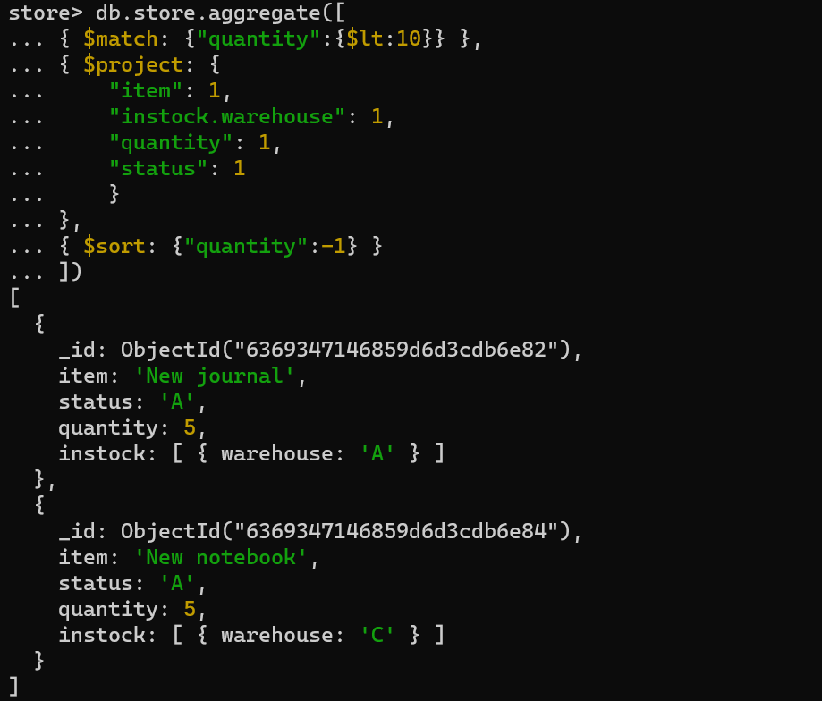

db.store.aggregate([

{ $match: {"quantity":{$lt:10}} },

{ $project: {

    "item": 1,

    "instock.warehouse": 1,

    "quantity": 1,

    "status": 1

    }

},

{ $sort: {"quantity":-1} }

])

Q4: Write a Cursor for a query that looks for items with status D. Iterate over each item and update it with a new field (year) and value (2022).

For accessing the items with status D.

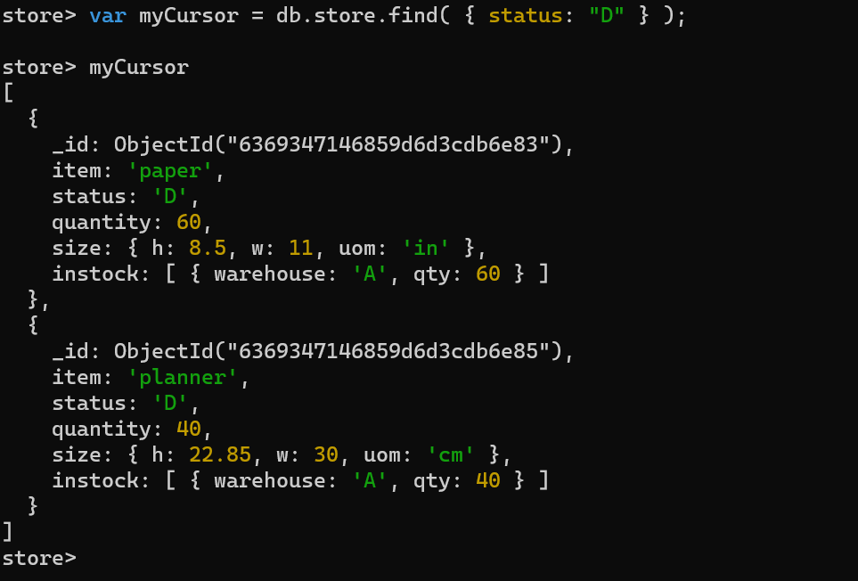

var myCursor = db.store.find( { status: "D" } );

myCursor

For accessing adding the new field year and adding year 2022.

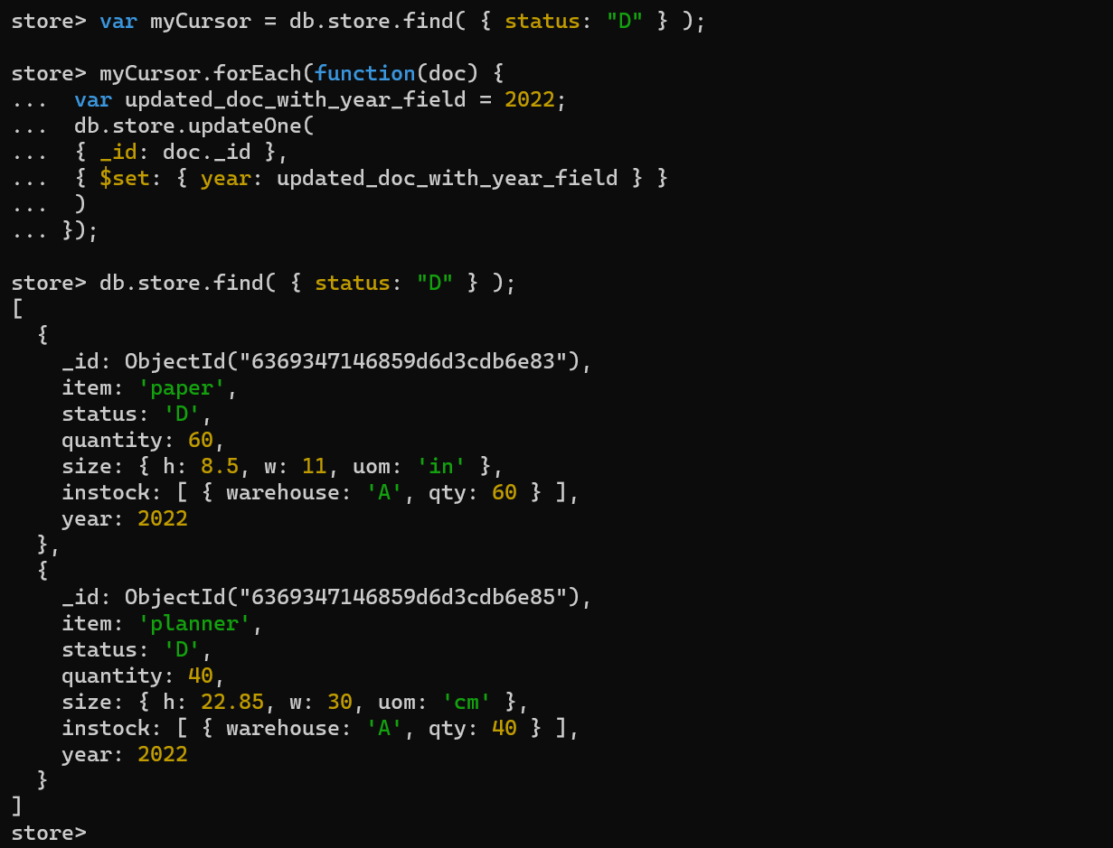

var myCursor = db.store.find( { status: "D" } );

myCursor.forEach(function(doc) {

 var updated_doc_with_year_field = 2022;

 db.store.updateOne(

 { _id: doc._id },

 { $set: { year: updated_doc_with_year_field } }

 )

});

db.store.find( { status: "D" } );